**(Front Page of Jacket with Logos and Company details)**

**Third Party Calibration, Industrial Inspection & Testing Services**

Calibrations, Inspection, Testing and Certification of Industrial tools / equipment and other assets are mandatory part of predictive / proactive maintenance activities.

Third Party certifications are required not only to comply with regulatory and client requirement but also to fine tune industrial processes, ensure safety of workers and Integrity of equipment / plants. AIMS is maintaining ***one stop shop*** for all such services.

**(Insert No. 2 Page 1)**

**Lifting Equipment Inspection, Testing and Certifications**

1. Visual and Magnetic Particle Inspection, Proof Load Testing and Certifications for;
2. Power Hoist, Beam Lifters, Shifters and Stackers.
3. Mobile, Crawler, Gantry, Electric Overhead, Slew Jib & Tower Cranes.
4. Chain Hoist, Lever Hoist, Sheave Blocks, Jacks and Pallet Trucks.
5. Cargo / Passenger Lift Elevators and Escalators.
6. Rigging Gears i.e. slings, belts, shackles, Eyebolts, Hooks, Master Links etc.
7. Excavator, Grader, Wheel Loader, Bulldozer, Earth Compactor and Dumper.
8. Vehicles i.e. all types of trailers, Trucks and other automobiles.
9. Access work plat forms, passenger lifts, baskets and scaffolding etc.
10. Fall Protective Equipment i.e. Full Body safety harness, Land yard, fall arrestors.
11. Training and Certification for Crane and Fork lift Operators.

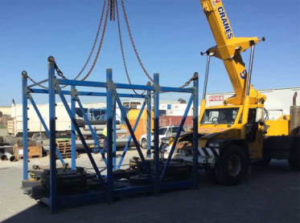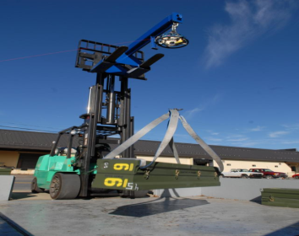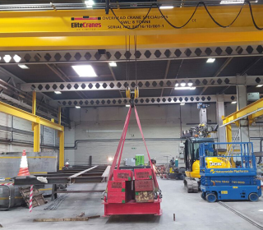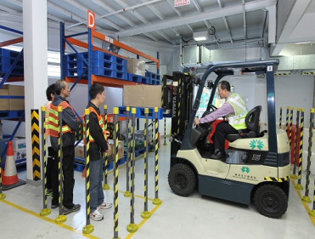

**(Insert No. 2 Page 2)**

**Non-Destructive Inspection and Testing Services**

AIMS is using following non-invasive, non-destructive techniques to determine the integrity of a material, component and structure for finding surface / internal flaws (if any) without interfering in any way with the integrity of material and its suitability for service;

1. Dye Penetrant Testing.
2. Magnetic Partial Inspections.
3. Ultrasonic Flaw Detection and Thickness Gauging.
4. Material Hardness Testing.
5. Coating Thickness Gauging.
6. Baroscopic Inspection.
7. Eddy Current Testing.
8. Holiday Detection.
9. Positive Material Identification.
10. Radiographic Testing.

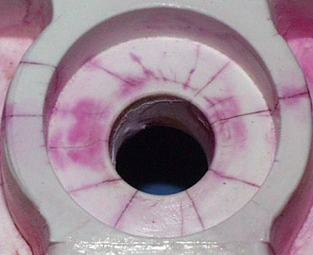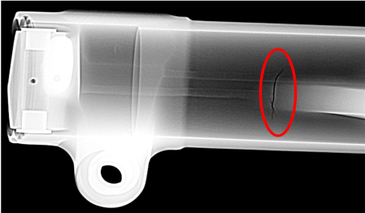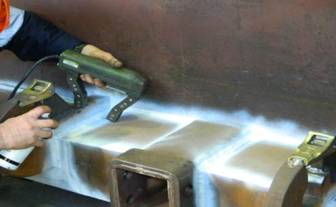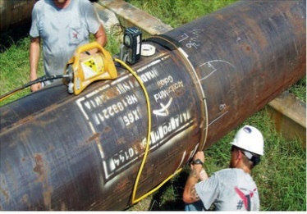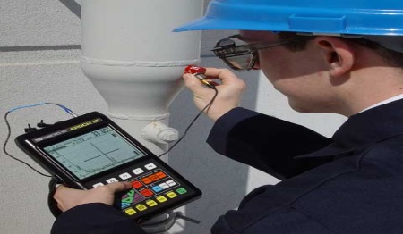

**(Insert No. 3 Page 1)**

**Integrity Measurement and Life Extension through Cathodic Protection**

**For Unprotected Facilities, We Offer following Services and supplies;**

1. CP System feasibility, initial estimation, site investigations.
2. Soil and water analysis.
3. Proposition of required CP system and isolation / resistance testing.
4. Project Planning and Selection of Test Procedures.
5. Initial Testing and Monitoring for data collection.
6. CP System Design, Preparation of BOQ and final project costing.
7. Supply of Materials as per BOQ (Optional).
8. Manufacturing of Transformer Rectifier Unit (if required).
9. Underground pipeline location and depth cover profiling.
10. Preparation of Ground bed and installation of anodes.
11. Installation of rectifier and joint bonding, monitoring and testing commissioning.

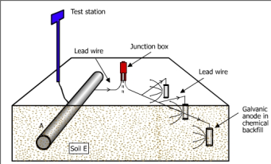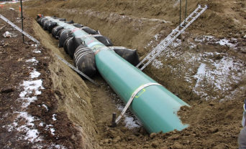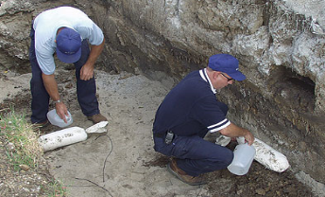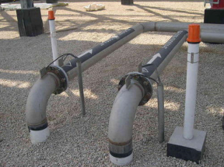

**(Insert No. 3 Page 2)**

**For Existing CP System, AIMS can offer following Services,**

1. Routine Monitoring of CP System.
2. Coating integrity / Inspections.
3. CP System Audits and Trouble shooting.
4. Monitoring and repairing of Transformer Rectifier Units.
5. Current drainage Surveys.
6. Soil resistivity surveys and ground bed locating.
7. Electrical Continuity, isolation and resistance.
8. Potential profiles; Annual and close interval surveys.
9. Stray current and interference studies.
10. Specialist Surveys (CIPS, DCVG, Pearson etc.)
11. Underground cable location and damaged cable fault findings.

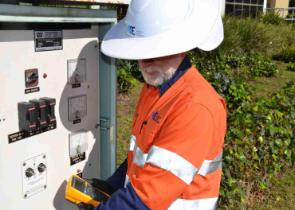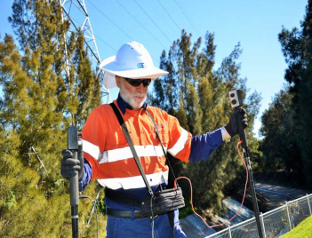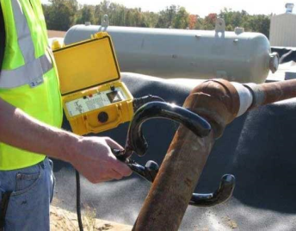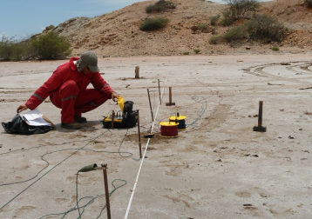

(Insert 4 page 1)

**Electrical Safety Testing for Household Electrical Appliances**

AIMS are also offering services of electrical safety testing for Industrial/house hold electrical appliances and tools for pre-shipment inspection. As per IEC Standard 60335-1, Following tests are available;

1. L-N mains volts, wiring and protective earth status.
2. Insulation Resistance test at 500V for Class I, II and III Appliances.
3. Protective Earth Bond Test at 200 mA and 25 Amp for class I Appliances.
4. Substitute Leakage Current.
5. Load Leakage and Touch Current.
6. Appliance Power and Load Current Test.
7. Protected Extra Low Voltage Test.
8. IEC Lead Test.
9. Trip Current and Time Test for Residual Current Devices.
10. Earth Resistance for mains earth System.

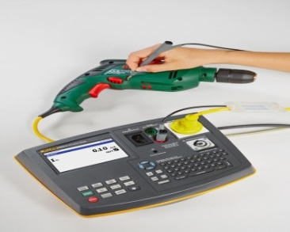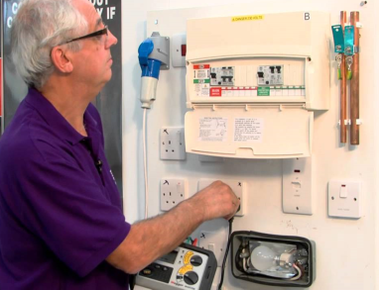 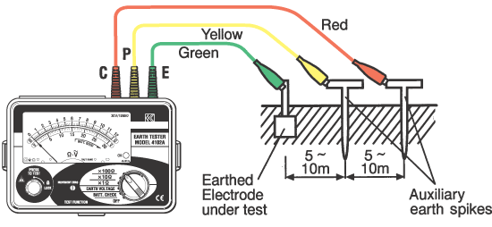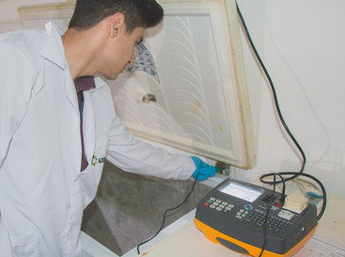

(Insert No. 4 Page 2)

**Medical Electrical Devices (Basic Safety and Essential Performance Testing)**

AIMS is offering services of Basic Safety testing for Medical Electrical Appliances as per the requirement of IEC Standard 60601-1. We are performing following test with state of the art tester Bio Tek 601;

1. L-N mains volts, wiring and protective earth status.
2. Insulation Resistance test at 500V for Class I, II and III Appliances.
3. Protective Earth Bond Test at 1 A and 10 A for class I Appliances.
4. Leakage Current Earth and Enclosure.
5. Patient Leakage Current.
6. Patient auxiliary leakage Current.
7. ECG Electrical Safety Test.
8. IEC Lead Test.
9. Trip Current and Time Test for Residual Current Devices.
10. Earth Resistance for mains earth System.

Calibration and Performance analysis of Biomedical Equipment and devices through simulation and control of patient related parameters. AIMS Scope of Biomedical Calibration is as under;

1. Electrosurgical Units.
2. Defibrillators.
3. Pace Makers.
4. Infusion/Syringe Pumps.
5. Incubators and Ventilators.
6. Patient Monitors.
7. Pulse Oxy Meters.
8. ECG Machines.
9. Ultrasound and X-Rays machines.
10. Pressure Temperature / Humidity and Flow devices.

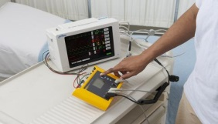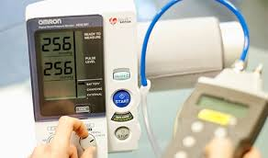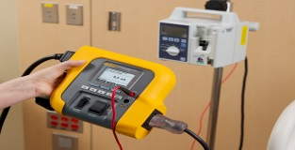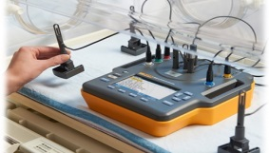

(Insert No. 5 page 1)

**Metrology Training and Consultancy**

**Target Audience**

These Courses have been designed for;

* On the Job Apprentices.
* Inspection engineers and technicians.
* Testing Engineers and technicians.
* Calibration engineers and Technicians.
* Maintenance engineers and technicians.
* Plant operators and QC Inspectors.
* Planning Engineers and decision makers.
* Equipment Inventory in-charges and purchasers.

**Training Benefits**

Adding Values to Your Systems/Organization through;

* Compliance with HR training requirements and ISO Standards.
* Best Choice and competitive purchase of Test Equipment.
* Enhanced confidence on measurements standards/systems.
* Fine tuning of operations/system through accurate measurements.
* Reduction in operational mistakes with expensive consequences.
* Better measurement and monitoring of OHSE activities.
* More reliable QC inspection/testing for raw material and finished goods.
* Waste reduction through improved measurement best practice.

**About Trainer;**

AIMS pool of freelance trainer consists of two instructors. Each having;

* Attended number of metrology related trainings in Pakistan and Abroad.
* + 20 years of national / international experience in the metrology field.
* Provided training to various organization in the Middle East and Pakistan.
* Worked as Technical Assessor with PNAC, ENAC and GAC.
* Headed number of accredited 17025 labs in the Middle East and Pakistan.

(Insert No. 5 Page 2)

Following Training Courses are Available from AIMS Metrology;

MTC01; 6 Questions about Calibration.

MTC02; An Introduction to World Metrology System.

MTC03; Precision Pressure and Vacuum Calibraton.

MTC04; Temperature Metrology Concepts and Realization.

MTC05; Humidity Measurement techniques and applications.

MTC06; Precision Mass Metrology and Weighing Scale Calibration.

MTC07; Force Metrology and Calibration of Load Cells.

MTC08; Calibration of Mechanical / Electrical and Hydraulic Torque Wrenches.

MTC09; Precision measurement of volume in analytical labs.

MTC10; Pipetting techniques in micro volume measurement.

MTC11; Fluid Level Measurement in Process Industry.

MTC12; Fluid measurement techniques and Flow Meters.

MTC13; Dimensional Metrolgoy and Tooling

MTC14; Precision Electrical Measurement

MTC15; Time Frequency and RPM Measurement

MTC16; Calibration of Energy and Power Meters

MTC17; Acoustics Noise and Vibration Meterology

MTC18; Measurement Uncertainty Fundamentals

MTC19; UOM Calculation in Calibration and Testing Labs.

MTC20; Measurement Uncertainty GUM Approach.

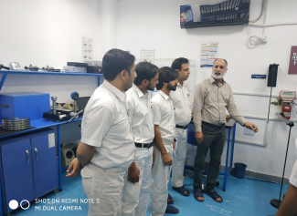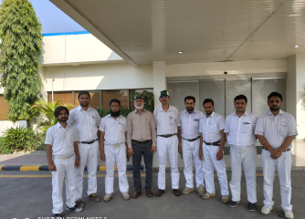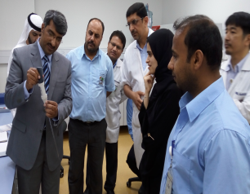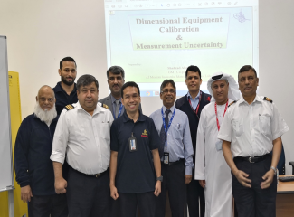

(Insert 6 Page 1)

**QMS Consultancy**

AIMS Management having ample experience of documentation,

implementation, staff training, internal and external audits for QMS like

ISO/IEC 17025: 2005, ISO 17020, 14001, 18001 and 9001 could be the right

choice for consultancy and implementation of QMS.

Consultancy would be comprising of following steps;

● Preliminary meeting and visit of organization to understand the nature

of business.

● Review of existing documentation and procedures.

● First training session for awareness of the required QMS system.

● Preparing complete documentation package for the organization.

● Two to three training sessions for familiarization of management with

QMS Documents.

● Guiding the organization for the implementation of the system.

● Internal Audit of the organization for GAP analysis.

● Submission of application to the certification/accreditation body.

● Preparation for the external Audit.

● Assisting the organization for CAPA resulting from external

Audit/Assessment.

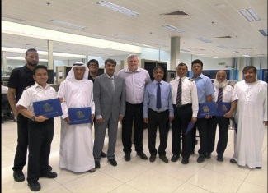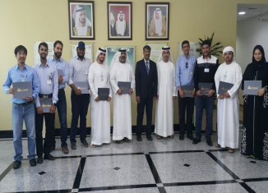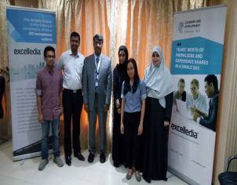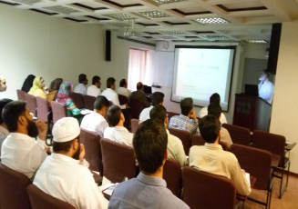

**(Insert 6 Pages 2)**

**QMS Trainings**

AIMS offer comprehensive trainings for the following ISO standards;

● ISO / IEC 17025: 2017

● ISO 17020: 2012

● ISO 9001: 2015

● ISO 14001: 2015

● OHSAS 18001: 2015

For all above ISO standards, three levels of training are available;

● Level I (Awareness of the general requirements of the standard).

● Level II (Implementing the standard in an organization)

● Level III (Internal Auditing of the standard).

Complete Consultancy Package for ISO / IEC 17025: 2017 consists of;

|  |  |
| --- | --- |
| 1 | Training on Requirement and Implementation of ISO 17025:2017. |
| 2 | Preparation of Quality Manual and SOPs. |
| 3 | Review of existing SOPs and Formats and its alignment with Standard requirement. |
| 4 | Training on Uncertainty of Measurement as per UKAS M3003 ver 2012 (1 day) |
| 5 | Training on Internal Audit of QMS System. |
| 6 | Training on Internal Quality Control Acivities i.e, Intermediate checks, PT and ILC etc. |
| 7 | Internal Audit of system (Once Implemented before PNAC Visit) |
| 8 | Consulting for Closing of PNAC NCR for pre/full assessment visit. |

**Calibration/Verification of Flow Meters**

**Calibration of Liquid Storage Tanks**

 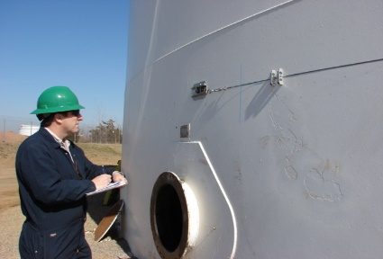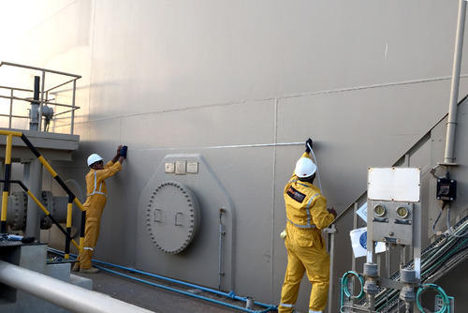

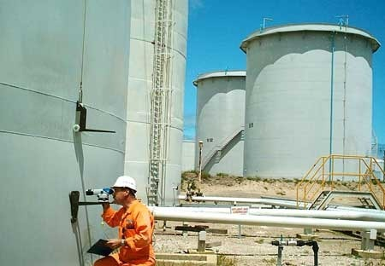 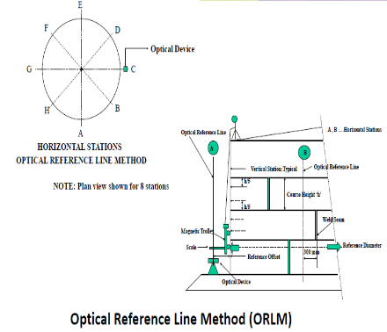

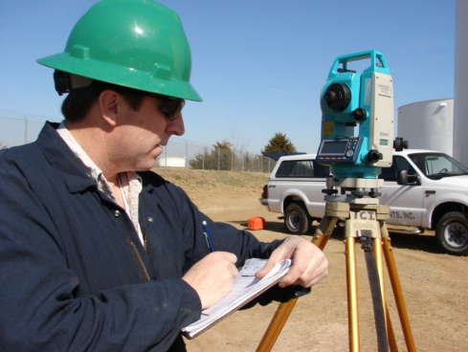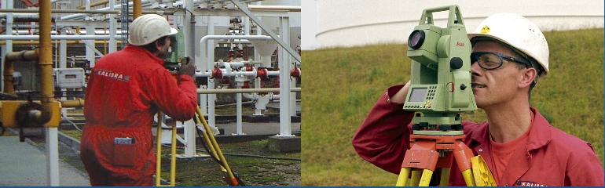

*Calibration is method for accurately determining the capacity of a tank or part of it and expressing the capacity as volume for a given height of the liquid contained.*

Tank Calibration is a must for custody transfer, mass balances in refineries and volume balances in tank farms and pipe line terminals.

**American Petroleum Institute’s** Manual of Petroleum Measurement Standards Chapter 2 outlines procedures necessary for calibrating closed storage vessels larger than a drum, and methods for computing the volumes contained therein;

* –API Chapter 2.2 A: Manual Tank Strapping Method
* –API Chapter 2.2 B: Optical Reference Line Method
* –API Chapter 2.2 C: Optical Triangulation Method
* –API Chapter 2.2 D: Internal Electro Optical Distance Ranging Method
* –API Standard 2555: Liquid Calibration

**Calibration of Fuel Dispensers, Flow Meters / Totalizers and Process Tanks**

Al Meezan Industrial Metrology Services under the auspices of Punjab Weights and Prices Bureau provides services for the calibration / verifications of fuel dispensers and fuel storage tanks and volume proving tanks.

AIMS also provides services for calibration of flowmeters, totalizers and liquid calibration of process tanks installed in process industry for measuring, monitoring and storing of process fluids.

Calibration is also offered for liquid weight measurement systems installed under silos, hoppers and liquid tanks for batching and mixing of process fluids.

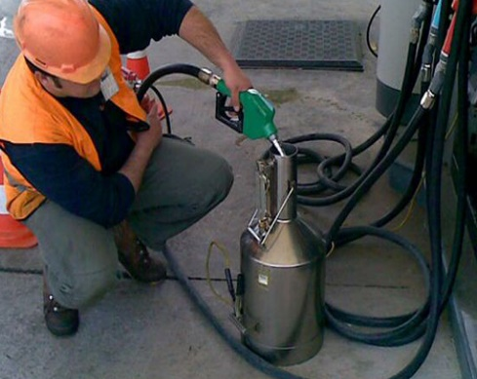 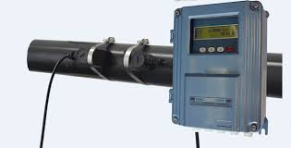 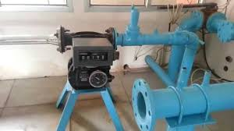 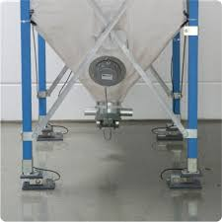 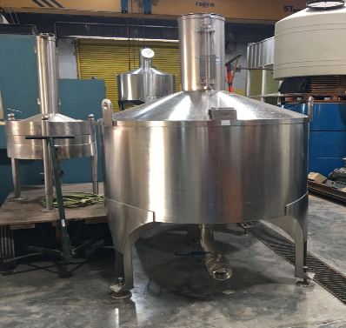

**(Last Cover Page)**

**Our Valued Clients;**

**Punjab Drug Testing and Research Centers.**

**Qarashi Research International**

**Forensic Science Agency Pakistan**

**Nestle Pakistan**

**Engroo Foods**

**Pepsi Cola International**

**The Coca Cola Export Corporation**

**US Denim Mills**

**Artstic Milliners**

**Nishat Mills Ltd.**

**National Transmission and Dispatch Company**

**Pak Elektron Limited.**

**Hydrocarbon Development Institute**

**Pakistan Petroleum Limited**

**Pakistan Oil Field Limited**

**Mari Petrolium Company Limited.**

**Sui Northern Gas Pipe Lines**

**Fatima Fertilizer**

**Parco Refinery Limited**

**Heavy Industries Taxila**

**Honda Atlas Cars**

**DG Cement**

**Best Way Cement**

**Mapple Leaf Cement**

**Emirates Airline (Engineering Dept.)**

**VIP Flight Operations**

**Century Paper and Board Mill**

**National University of Science and Technology (MBR)**

**Intertek Pakistan**

**SGS Pakistan**